Project Design Phase-II
Data Flow Diagram & User Stories

Date | 24-June-2025
Team ID | LTVIP2025TMID55631
Project Name | ShopEz
Maximum Marks | 4 Marks

Data Flow Diagrams:
A Data Flow Diagram (DFD) illustrates how data moves within the Resolve Now platform. It captures how user interact with the system, how information flows between different components, and where the data is stored.
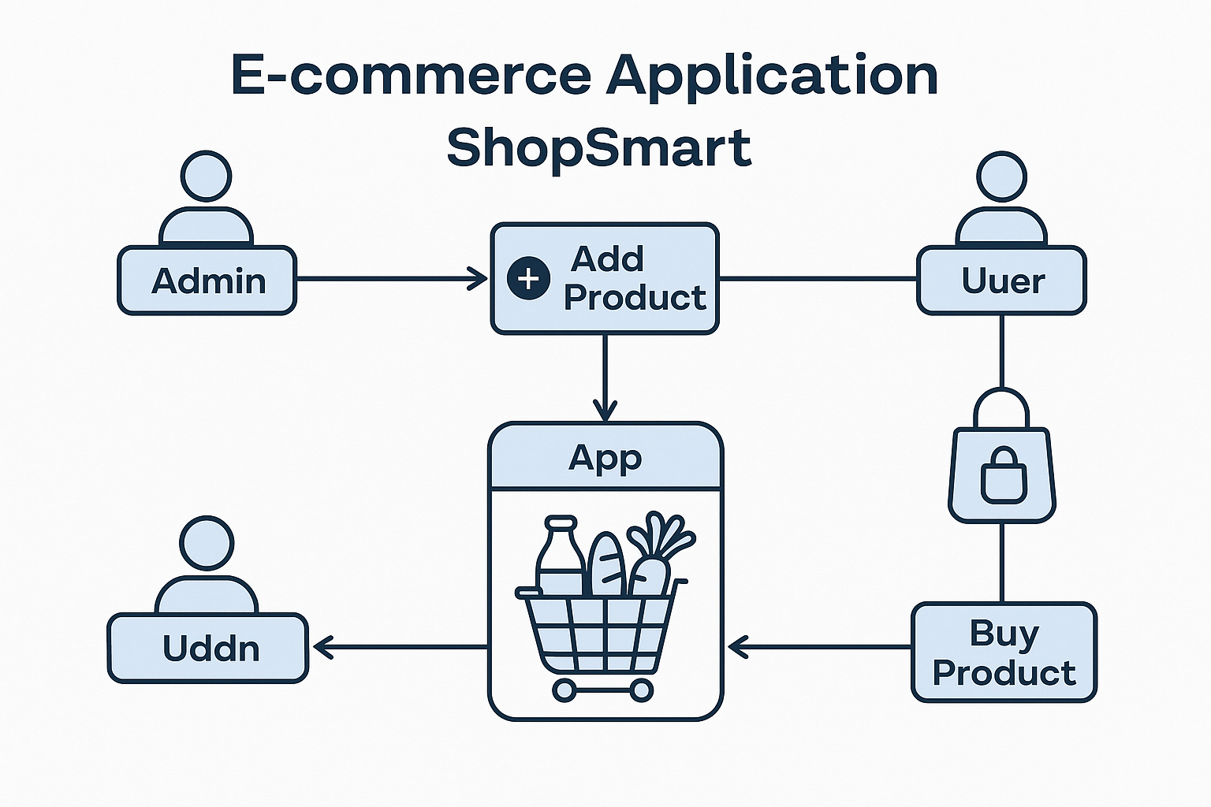

User Story Table – Shop Smart
User Type | Functional Requirement (Epic) | User Story / Task | Acceptance Criteria | Priority | Release
Admin | Product Management | As an admin, I can add new grocery products to the app. | Products appear in the product listing for users. | High | Sprint-1
Admin | Inventory Control | As an admin, I can update or delete existing products. | Changes are reflected in  real-time to users. | High | Sprint-1
User | Product Browsing | As a user, I can browse all available  grocery products. | All listed products are  visible with details like  price and quantity. | Medium | Sprint-2
Client | Add to Cart | As a user, I can add items to my  shopping cart. | Selected items appear  in the cart with correct  quantity and total. | High | Sprint-2
Admin | Order Management | As an admin, I can view and process  user orders. | Admin dashboard shows  new orders and their  statuses. | High | Sprint-1

